Style Guidelines for Final Year Project ReportsScan Shop & Exchange

Final Year Project Proposal

Session 2018-2022

A 4th Year Student

A project submitted in partial fulfilment of the

COMSATS University Degree

Of

BSc. (Hons.)BS in Computer Science



Department of Computer Science

COMSATS University Islamabad, Attock Campus

14 April 2021

**Project Registration Form**

|  |  |  |  |  |  |  |  |  |
| --- | --- | --- | --- | --- | --- | --- | --- | --- |
| Project ID (for office use) | |  | | | | | | |
| Project Title | | Scan & Shop | | | | | | |
| Type (Nature of project) | | [ ] Desktop Application [ ] Web Application [ ] Mobile Application | | | | | | |
| Area of specialization | |  | | | | | | |
| **Project Group Members** | | | | | | | | |
| Sr.# | Registration No | | Student Name | CGPA | Email ID | | Contact No | Signature |
| 1. | SP18-BCS-009 | | Muhammad Faizan | 3.64 |  | |  |  |
| 2. | SP18-BCS-024 | | Hamza Zarin | 3.58 |  | |  |  |
| 3. |  | |  |  |  | |  |  |
| Name & Signature of Program Coordinator to certify that  Are the students eligible for FYP? [ ] Yes [ ] No | | | | | |  | | |

# Consent and Plagiarism Certificate from Supervisor

I affirm to accept and supervise the above-mentioned students throughout the project duration. This is to certify that this FYP proposal is checked by me and the similarity index is ________% that is less than 19%, an acceptable limit by HEC. Report is attached herewith.

Name of Supervisor: M. Jamal Ahmed Co-Supervisor (if any):____________________

Designation: Lecturer Designation: _____________________

Signature: _____________________ Signature: _____________________

**Approval of FYP Management Committee**

Committee Member 1: Name: _____________________

[ ] Accept [ ] *Defer [ ] *Reject Signature: _______________

*Remarks: _____________________________________________________________________

Committee Member 2: Name: _____________________

[ ] Accept [ ] *Defer [ ] *Reject Signature: _______________

*Remarks: _____________________________________________________________________

Convener: Name: _____________________

[ ] Accept [ ] *Defer [ ] *Reject Signature: _______________

*Remarks: _____________________________________________________________________

**Project Abstract:**

We are developing an android application which will be used forshopping but our application will be different from other common shopping applications. Our application has the scan and shop feature where a person scan an image of product and will be transferred to shopping sites where he can find that product as well as similar products. Another interesting feature of our application will be barter exchange, where user will not only be able to buy new and used products but also they would be able to find the replace of their product near to them, It means if someone wants to replace any product with any other product he wants, so our application will make it possible for them by finding the correct person who will be also willing to replace the item. Moreover, our application will also provide similar itemsbased on item-to-item and user-to-user collaborative filtering so that they can also try them as well.

**Introduction:**

This project is aimed at developing an android application to make shopping easy. Using this Application, customers will easily find goods they will be looking for, but it is not easy to define something you have seen in specific keywords. That’s the area where our application will be useful, because we will find the goods user will looking for by taking the picture, For example: if someone likes his/her friend’s watch and wantsthe same, He/she should have to take a picture of that watch and our application will find that watch for him/her from where they can buy it. It will be the easiest way to purchase products.

As Shopping is one of the area where more and more people find it convenient to buy products, but sometimes people don’t want to buy product, they want to just barter their product with others. Our application will provide that functionality as well and also near to them by tracking their location.

We will also provide a recommendation list of items they may also like. That recommended list will be containing similar items they searched or looking for.

**Motivation and Scope:**

The motivation we got from our environment. As shopping was introduced in 1995. It was the time where people prefer to buy products from market. In 20th, century shopping catch a heat, people use applications to buy products to save their time. It is the age of technology and time has come to create the way we use to buy products from stores. People waste lots of time while buying products from stores by visiting them, because any store or Mall is very huge in size and it is very difficult to find the thing that you want for yourself to buy. To resolve this problem different shopping apps were created, And it made it possible to save the time of going to the store but one problem left and that was of finding the correct product, as looking for products they want to buy in just scrolling shopping sites is also a waste of time. As this is a modern era and everyone wants things to be happen on just one click. For this purpose we are going to develop an application that will be able to save time because it take lots of time to search for products you are looking for in keywords. So to tackle this, User just have to open our application, take the picture and our application will find that specific site or website where the product will be present , if there is no product available then our application will find some related one and also will give some suggestions and recommendations. One and the most interesting feature of our application will be barter exchange, it means if someone wants to exchange his product with any other product he likes, he has to just click on the barter button and write his choice of product in the textfield and our application will find the correct match for user, if there is none then some suggestions and recommendations will be provided. We will also provide the facility of location as GPS tracking, the user has just to select the place from where they want to buy or exchange products. To cut the story short, our main goal is to bring change in way people use to shop and to make the shopping easy to the maximum possible extent.

**Related Work:**

**Daraz:**

Daraz is an [online marketplace](https://en.wikipedia.org/wiki/Online_marketplace) and logistics company which operates in markets of [South Asia](https://en.wikipedia.org/wiki/South_Asia) and [Southeast Asia](https://en.wikipedia.org/wiki/Southeast_Asia). It was founded in 2012 as an online fashion e-commerce marketplace in Pakistan.

**Ali Express:**

AliExpress is an [online retail](https://en.wikipedia.org/wiki/Online_retail) service based in [China](https://en.wikipedia.org/wiki/China) that is owned by the [Alibaba Group](https://en.wikipedia.org/wiki/Alibaba_Group). Launched in 2010it is made up of small businesses in China and other locations, such as [Singapore](https://en.wikipedia.org/wiki/Singapore), that offer products to international online buyers. It is the most visited e-commerce website in [Russia](https://en.wikipedia.org/wiki/Russia) and was the 10th most popular website in [Brazil](https://en.wikipedia.org/wiki/Brazil).

**Why Our Project is Different from Other Applications?**

These are the most popular applications used for shopping. But none of them provides the functionality of scan and shop as well as item exchange. These features make our application unique.

**System Architecture and Features:**

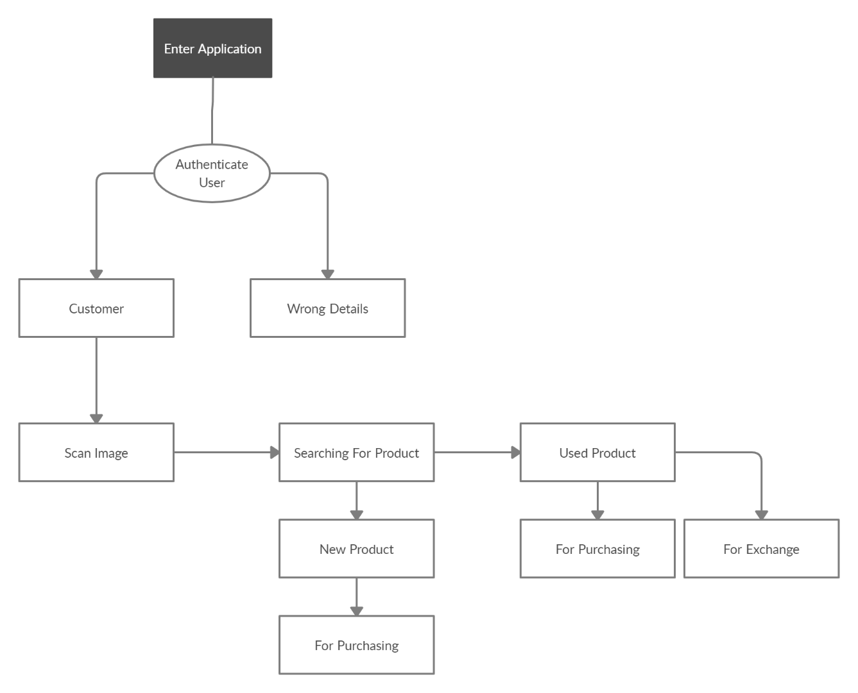

Figure 1: System Architecture

The Figure 1 shows the data flow diagram of our application. User will open our application then he/she will login by providing valid user name and password. Then he/she can scan image to find the product. After that new and used products available on different sites will be shown, from where he/she can buy or exchange products if both parties are interested in exchange.

**Goals and Objectives:**

* Our goal is to create a full flash android application that will bring a revolution in shopping industry.
* The working of our project will be image processing by taking the picture with camera andfinding the places from where people will buy or barter that thing.
* The whole searching process will be done from the picture.
* Our application will also provide similar items based on item-to-item and user-to-user collaborative filtering so that they can also try them as well.
* The main objective of our project is to make a user friendly interface and easy to use.

**Individual Tasks:**

Table 1: Individual Tasks

|  |  |
| --- | --- |
| **Task** | **Name** |
| Designing | Muhammad Faizan, Hamza Zareen |
| Coding | Muhammad Faizan, Hamza Zareen |
| Implementation | Muhammad Faizan, Hamza Zareen |
| Testing | Hamza Zareen |
| Debugging | Muhammad Faizan |

Table 1 shows the tasks which will be performed by both of us. Designing, Coding Implementation these are the tasks we will be performing together. But testing and debugging are the kind of tasks which will be performed separately.

**Key Milestones of the Project with Time:**

Table 2: Key Milestones

|  |  |  |
| --- | --- | --- |
| **Elapsed Time Since Start** | **Milestones** | **Deliverable** |
| 2 weeks | Supervisor Selection | Selected |
| 2 weeks | Proposal Writing | Submitted |
| 4 weeks | Learning | Gathering Knowledge |
| 4 weeks | AI Learning | Gathering Knowledge |
| 4 weeks | GPS Learning | Gathering Knowledge |
| 3 weeks | Requirements Learning | Requirement Analysis |
| 3 weeks | Design | Flow Charts & UML |
| 10 weeks | Coding | Coding |
| 2 weeks | Testing & Debugging | Correcting Errors if any |
| 4 weeks | Finalization | Finalization |
| 3 weeks | Final Documentation | Documentation |

Table 2 shows the key milestones and time required to achieve that milestone.

**Gantt chart:**

Figure 2: Gantt Chart

Figure 2 shows the Gantt chart of our project. It shows our tasks, and their completion dates.

**Tools and Technologies:**

* Android Studio.
* Java.
* XML.
* Python.
* Figma.
* Flask Framework.
* Firebase.